https://www.klix.ba/vijesti/bih/sporni-studij-na-fpn-u-sarajevu-sud-i-definitivno-proglasio-nevazecim-vise-od-300-diploma/151014059?utm_source=chatgpt.com
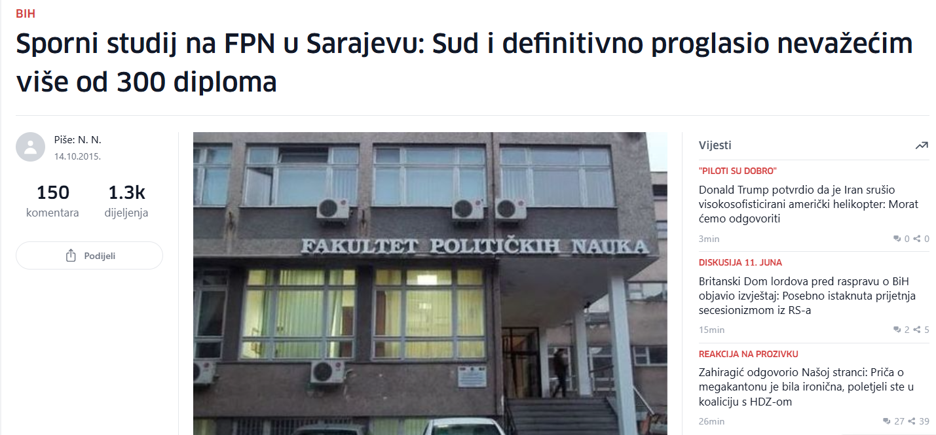

https://www.zurnal.info/clanak/odbijena-zalba-fpn-a-ponistavaju-se-diplome-za-626-magistranata/19369?utm_source=chatgpt.com

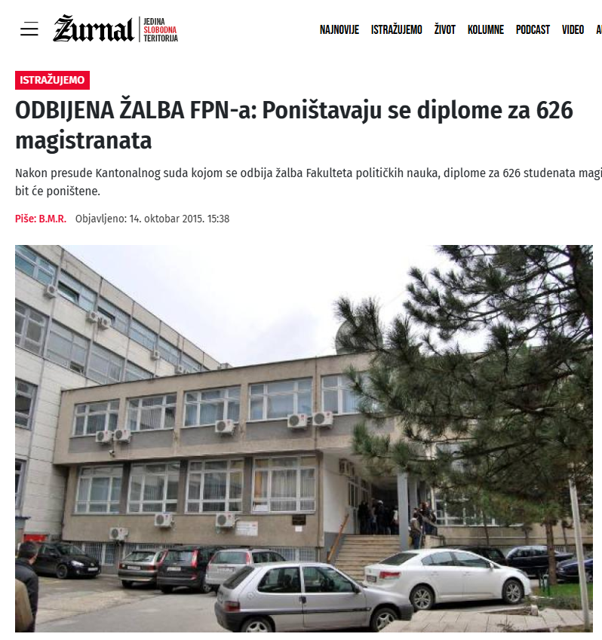

https://www.klix.ba/vijesti/bih/sud-utvrdio-fpn-u-sarajevu-nelegalno-uzimao-novac-od-studenata/130430039?utm_source=chatgpt.com

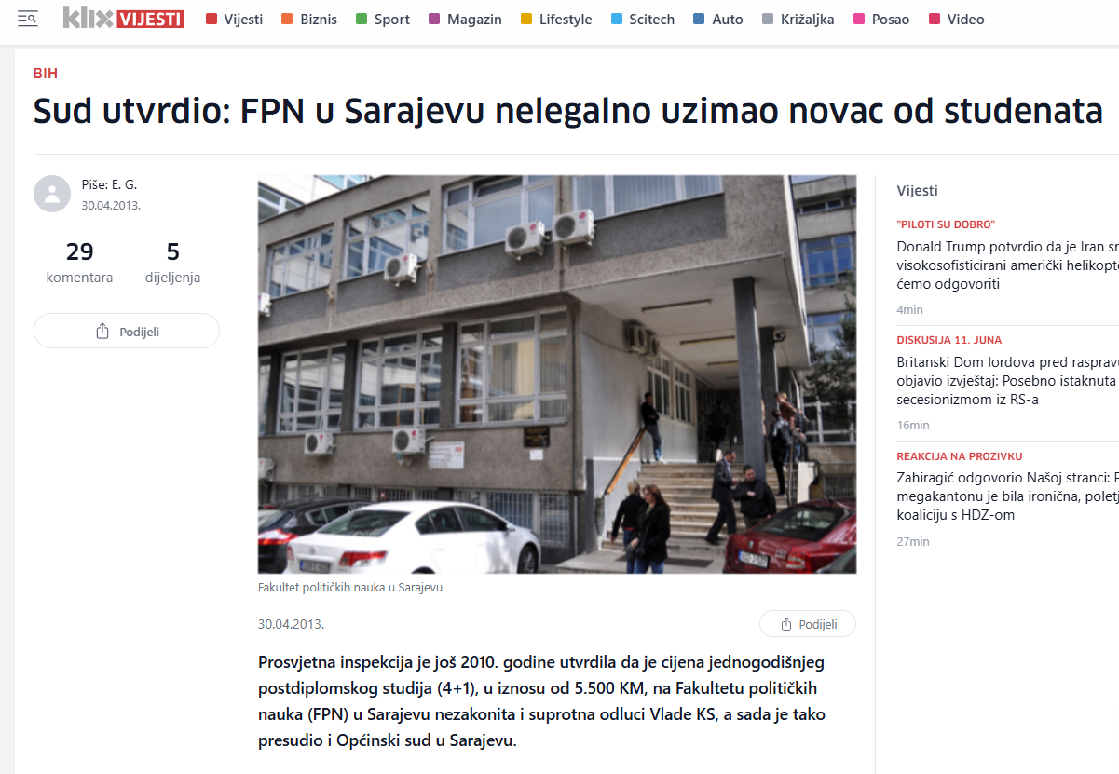

https://inforadar.ba/korupcija-na-univerzitetu-u-tuzli-potvrdena-optuznica-protiv-rektorice-za-zloupotrebu-polozaja/?utm_source=chatgpt.com

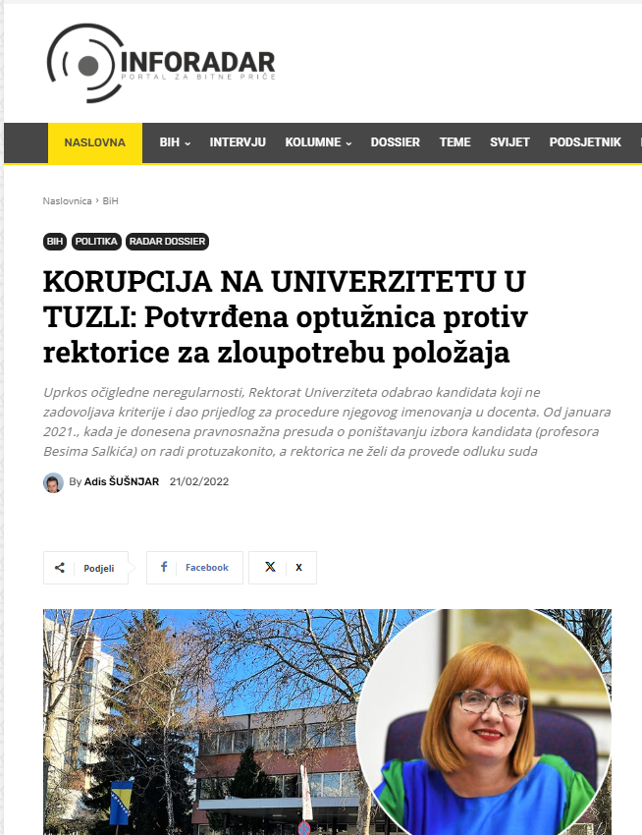

https://zurnal.info/clanak/predrag-ceranic-nezakonito-izabran-za-dekana/20345?utm_source=chatgpt.com
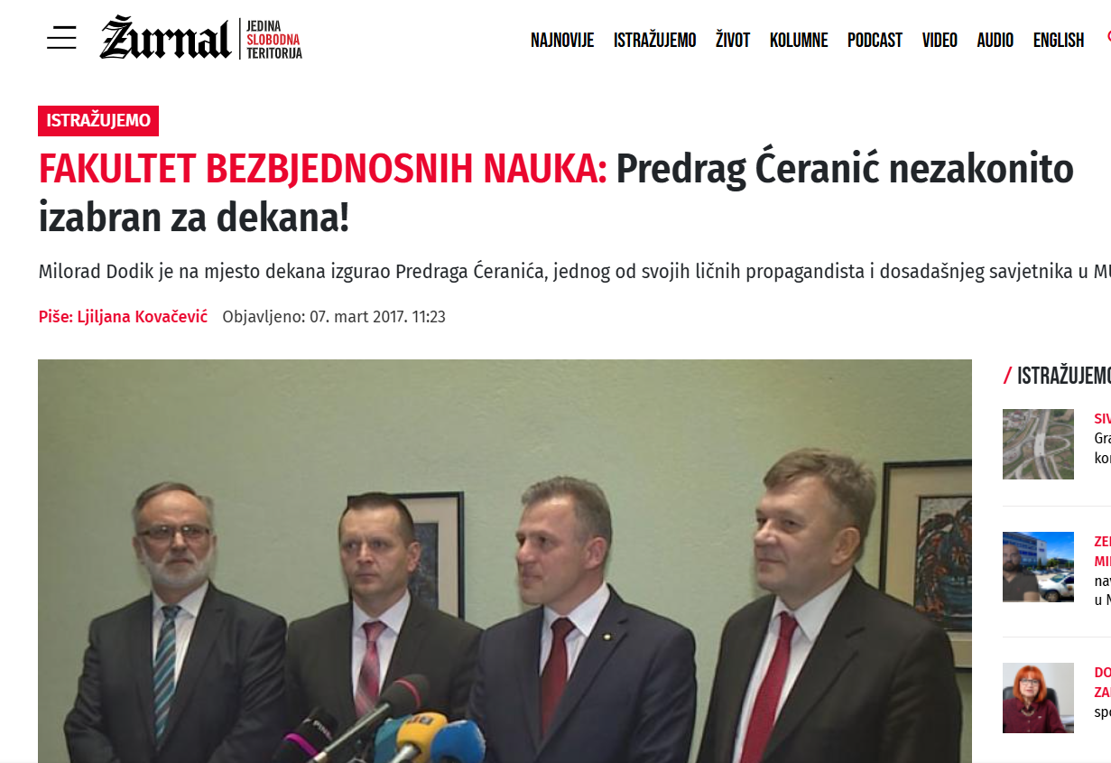

https://zurnal.info/clanak/prekrsen-statut-u-komisiji-plagijator-i-doktor-zastite-na-radu-/21016?utm_source=chatgpt.com

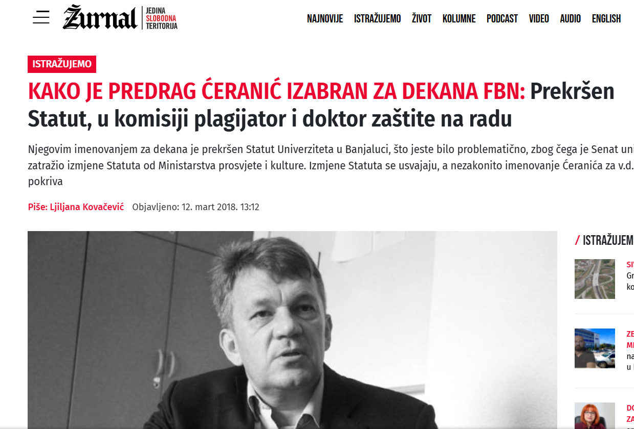

https://zurnal.info/clanak/zakoni-i-pravila-ne-vaze-za-dodikove-ljude/23910?utm_source=chatgpt.com
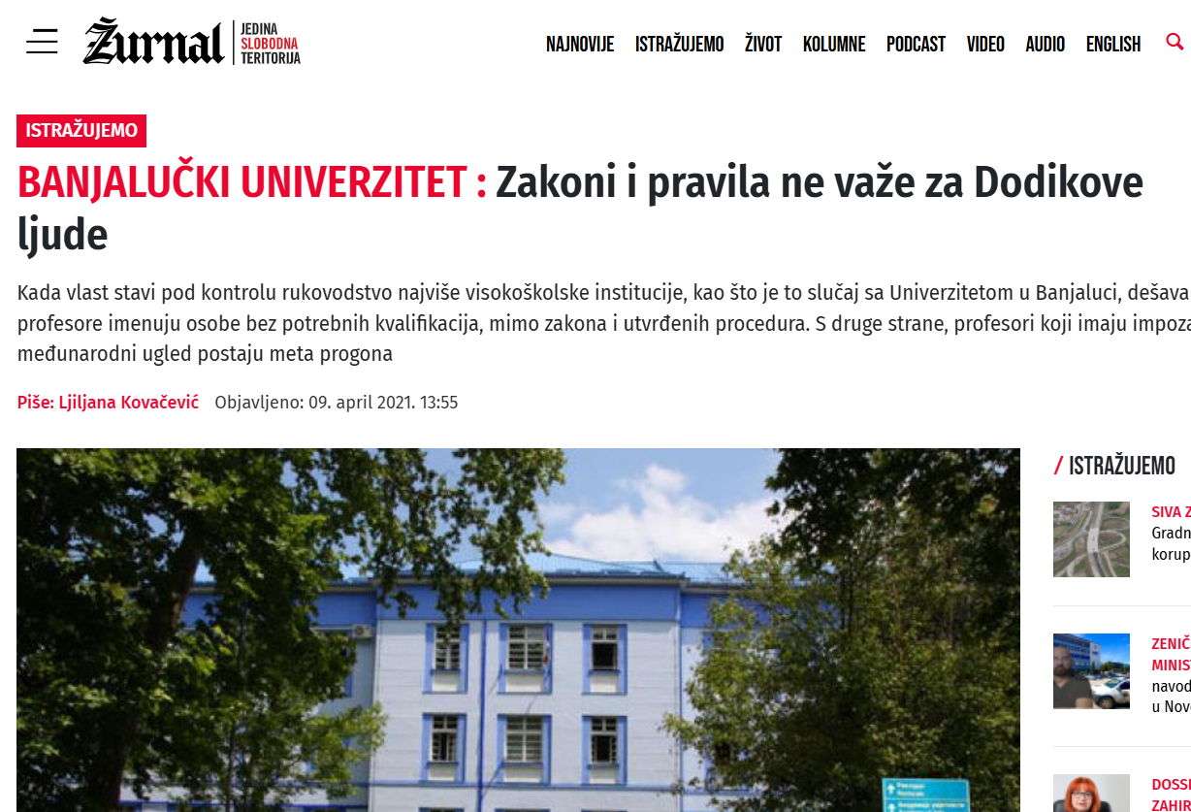

https://zurnal.info/tag/univerzitet-u-banjoj-luci?utm_source=chatgpt.com

